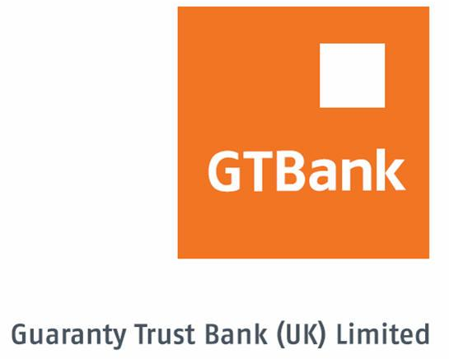

GTBANK UK GeNS APPLICATION FORM – BUSINESS ACCOUNTS

The Guaranty Trust Bank electronic Notification System, popularly referred to as GeNS is a free email alert system that notifies you about monies either coming in or going out of your account(s) with us.

Kindly complete the next few fields in order for us to process your GeNS email alert application.

ORGANISATION
SORT CODE |  |  |  |  |  | ACCOUNT NUMBER |  |  |  |  |  |  |  | EMAIL ADDRESS¹ (block letters)
4 | 0 | 6 | 2 | 5 | 4
4 | 0 | 6 | 2 | 5 | 4
4 | 0 | 6 | 2 | 5 | 4
4 | 0 | 6 | 2 | 5 | 4

- Email addresses can be individual or group email addresses depending on the size of the business unit within your organisation.

Please tell us how you want your email alerts

YOUR GeNS OPTIONS
Receive account balances along with GeNS email alert? | YES NO
Regardless of currency, alerts not required for amounts less than
Transaction types to receive GeNS email alerts for | ALL CREDITS DEBITS

TERMS & CONDITIONS OF SERVICE.

While GTBank UK will take utmost care in delivering the GeNS Service to customers, e-mail communications cannot be guaranteed to be secure or error-free; as information could be intercepted, corrupted, amended, lost, destroyed, arrive late or incomplete, or contain viruses. We do not accept liability for any such matters or their consequences.

GTBank UK reserves the right to discontinue the service in future

ACKNOWLEDGEMENT

We/I understand the terms & conditions of the service and in requesting updates from the GeNS alert system, we/I do so at our/my own risk and we/I am responsible for securing access to our/my email box(es). We/I also confirm that the members of the group email addresses supplied above are the intended recipients of the email alerts (if applicable).

___________________________ _______________
SIGNATURE DATE

___________________________ _______________
SIGNATURE DATE

